PRE-READING ACTIVITY - questions:
- Have you ever heard of King Arthur?
- Was he a real person or is this just a legend?
- Have you ever heard of Merlin, the wizard?
- Do you know what Excalibur was?

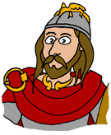
THE LEGEND OF KING ARTHUR

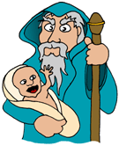
In 5th century, Britain was ruled by the High-King named Uther, who fell in love with Lady Igraine. Unfortunately, Lady Igraine was already married to Gorlois, the Duke of Tintagel. King Uther decided to marry Lady Igraine, so he took his army, fought with Gorlois and killed him. He married his love and they had a son named Arthur.

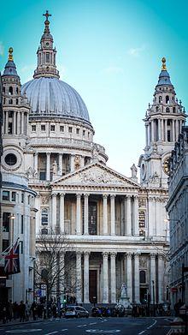
This was a very dangerous time and also the time of many attacks by Saxons, so King Uther gave his son to his wizard Merlin, to keep him safe. Merlin sent Arthur away to be raised in the countryside with his foster brother Kay. He never knew who his parents were.

When King Uther died, no one knew he had a son. Many people argued who the next king would be. Suddenly, a mysterious stone appeared in the yard of St.Paul's Cathedral in London. There was a message on it: “Whoever will pull the sword out, will be the rightful king of Britain.”

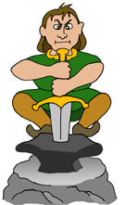
Years later, when Arthur was 15 years old, his foster brother Kay had his first knight's tournament. The family went to London. Arthur forgot to take Kay's sword, so went to look for one. He found a sword in the stone and took it out easily. When people noticed the sword, everyone wanted to know who had pulled the sword out. At first no one believed Arthur had done it. But later Arthur was crowned to be the King, even if eleven local kings would not agree and started a rebellion against Arthur.

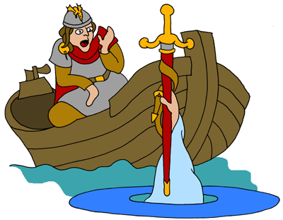
Merlin helped Arthur to rule Britain. He took him to the magic lake. The Lady of the Lake lived there, beneath the water. She gave Arthur a magic sword called Excalibur. If you used Excalibur in a fight, you would always defeat your opponent. If you had the scabbard (a container for a sword), you would always be protected from being hurt. Arthur led a big army against 11 rebels, fought many battles and won. The 11 kings agreed Arthur should be the High-King.
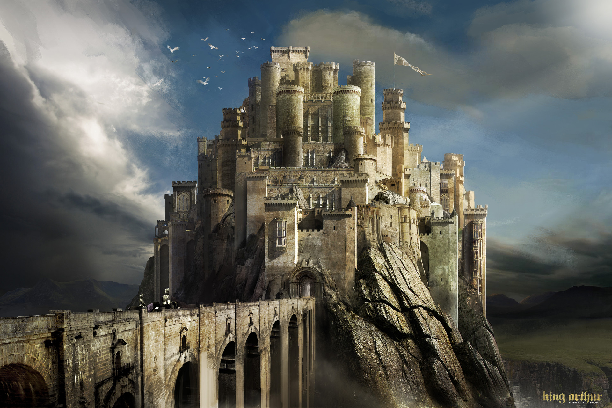
Arthur set up his royal palace at Camelot. When he was a bit older, he married a princess named Guinevere. She was the daughter of King Leodegrance of Cameliard. He gave Arthur and Guinevere a huge round table as a wedding present.

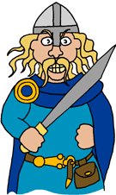
All the knights in the country wanted to be soldiers for their King, but only the bravest were allowed to sit at the round table. They were known as the Knights of the Round Table. They fought against the Saxons in many wars and finally defeated them at the Battle of Mount Badon. Everyone was happy and felt safe again.

Arthur decided to take his successful army even farther, to Europe. After a lot of fighting, the Roman Emperor agreed to give the western half of Europe to Arthur. The Knights of the Round Table had lots of adventures. Some rescued princesses, some fought dragons or bad knights and many of them went to look for a religious cup called the Holy Grail.
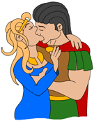
The best and the bravest of the Knights of the Round Table was called Sir Lancelot. He came from Brittany in France and was Arthur's best friend. He was also very handsome and Guinevere fell in love with him. They two would sneak away from the palace and spend time together. Arthur had no idea what was going on.

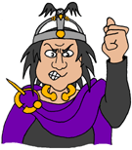
Arthur's nephew Mordred was an evil man, who found out what was going on between Guinevere and Lancelot and told Arthur. Lancelot ran away and Guinevere was taken to court where she should be burnt to death. Lancelot rescued her and they escaped to Brittany in France. Arthur took his big army to Brittany. He wanted to punish Lancelot and Guinevere.

Arthur left evil Mordred in charge, while he was away in Brittany. As Arthur had no children, Mordred was going to inherit the kingdom when Arthur died. He could not wait and told everyone Arthur had been killed in Brittany. People believed him and he made himself the High-King of Britain. Some people liked him because he had given away money. He even put together his own army.

Luckily, Arthur heard what was going on and returned back. The armies of Arthur and Mordred fought at the Battle of Camlann. Unfortunately, Arthur did not have his Excalibur sword with him. His sister Morgan Le Fay stole it from him. The battle was bad and few people were left alive at the end. Two of those were Arthur and Mordred. They fought each other in a single combat. Arthur killed Mordred but he was badly hurt himself.
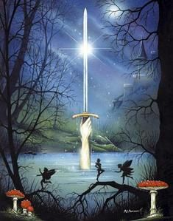
Arthur knew he was going to die. He gave Excalibur to Sir Bedivere. He told him to return it to the magical lake. Bedivere pretended to do that, but he hid the sword under a bush. Arthur asked him what had happened when he had thrown the Excalibur into the lake. Bedivere said it sank. Arthur knew right away he was lying. He told him to go and do the job properly. Bedivere threw the sword into the lake. He saw the hand of Lady of the Lake came out of the water to catch it.

When Arthur was dying a magical boat appeared to take him to the Isle of Avalon, where his sword Excalibur was forged and Lady of the Lake lived. Some believe that he died there soon afterwards; some say he went on the mysterious island to heal his wounds.

POST-READING ACTIVITY - questions:
- Who was the first High-King mentioned in the story? What was his name?
- Who was he in love with?
- Was his love single or married?
- How did he manage to marry her?
- Did they have any children?
- Whom did the King give his son?
- Why did he give it to Merlin?
- Where was Arthur raised?
- Did he know his parents?
- What happened when King Uther died?
- What magically appeared in St. Paul's Cathedral in London?
- What was the message on the sword?
- Why did Arthur and his family go to London?
- What did Arthur forget?
- Did Arthur find another sword? Where?
- Did people first believe that Arthur had pulled the sword out?
- Was he crowned the King?
- What is the difference between the King and the High-King?
- What did 11 local knights do?
- Who helped Arthur rule Britain?
- What happened with the Lady of the Lake?
- Why was it said that Excalibur had the magic power?
- Where did Arthur build his royal palace?
- Did he fall in love and get married? To whom?
- What did Guinevere's father give them as a wedding present?
- Who could sit there? What were the knights called?
- Did Arthur and his army defeat the Saxons?
- Where did they go after conquering Britain?
- What did the Roman Emperor give to Arthur?
- What kind of adventured did the Knights of the Round Table have?
- Who was Sir Lancelot?
- Who fell in love with him?
- Did Arthur know about them?
- Who told him?
- Who was Mordred? Was he a kind man?
- What happened to Lancelot?
- Was Guinevere burnt to death? What happened?
- What did Arthur do to punish his wife and Lancelot?
- Who took care of the kingdom?
- What did Mordred lie about?
- Did people like Mordred?
- What did Arthur do when found out about Mordred?
- Did he fight Mordred with Excalibur?
- Who died and who was hurt in the battle?
- What did Arthur order Bedivere to do with the sword?
- How could he recognize the lie?
- What happened in the end with King Arthur?
- What is Avalon?

The legend and the pictures are taken from the web page:
http://www.earlybritishkingdoms.com/kids/arthur_life.html

SONG Avalon from Bryan Ferry- Roxy Music:
You can put some music as a background when discussing questions:
http://www.youtube.com/watch?v=bpA_5a0miWk

VIDEO documentary - Youtube:
King Arthur legend: http://www.youtube.com/watch?v=Pa4v5gH3b18
part 1: http://www.youtube.com/watch?v=QLATxHGRqFg
part 2: http://www.youtube.com/watch?v=BUHusSgAPOo
part 3: http://www.youtube.com/watch?v=s6G7KD7h5PE
part 4: http://www.youtube.com/watch?v=GVrPjJvIzNw
part 5: http://www.youtube.com/watch?v=u9Muz0GCllM
The Isle of Avalon: http://www.youtube.com/watch?v=o3HAIdFy6Is
Vessel of the Fish: http://www.youtube.com/watch?v=3KryOnu5-7I

The movie King Arthur, 2004 (Clive Owen, Keira Knightley): http://www.imdb.com/title/tt0349683/?ref_=sr_1

