Choose the correct option.




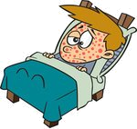




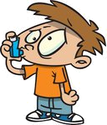










a) flu
b) measles
c) broken arm

a) sneeze
b) shivering
c) stuffy nose

a) headache
b) stomach ache
c) backache

a) cough
b) fever
c) retching

a) faint
b) fever
c) measles

a) measles
b) asthma
c) cold

a) bleed
b) broken arm
c) swollen thumb

a) toothache
b) stomach ache
c) headache

a) itch
b) rash
c) shivering

a) dizzy
b) heart attack
c) cold

a) cough
b) toothache
c) sore throat

a) cough
b) sore throat
c) retching

a) cold
b) retching
c) asthma

a) bleed
b) rash
c) faint

a) sore throat
b) stuffy nose
c) cough

a) headache
b) earache
c) toothache

a) sore throat
b) cough
c) dizzy

a) flu
b) chicken pox
c) headache

a) sneeze
b) cough
c) stuffy nose

a) swollen finger
b) broken leg
c) backache

