

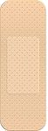

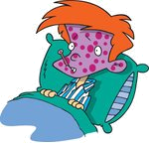
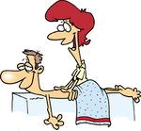
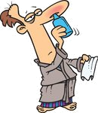
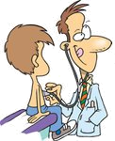
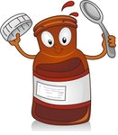

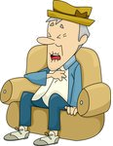
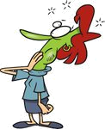

WHAT'S WRONG WITH YOU?
Find ten health problem and treatment words in the word search.

TARFCIPCACOLDOLRTEMVOUUDRASEKITGRECNAASTHMARESAZIPALAELPILLSCSZEVEARACHESWBANDAGE
Put the letters in the correct order.

1 aaheecr: _________________
2 gtnrheic:_________________
3 tiismvan:_________________
4 horetsotar:_________________
5 oeinintjc:_________________
6 uyrps:_________________
7 nolrgeebk:_________________
8 ecpixhnko:_________________
9 ohoatehtc:_________________
10 ndcmieei:_________________
Match the words and the pictures.
1 backache
2 chicken pox
3 syrup
4 dizzy
5 bandage
6 heart attack
7 massage
8 stuffy nose
9 retching
10 pills
11 sore throat
12 doctor
Find the odd one out.

1 cold – cough – rash – stuffy nose
2 fever – backache – earache - headache
3 chicken pox – headache – measles - rash
4 injection – medicine – syrup – X-ray
5 acupuncture – hospital – massage – diet
6 bleed – dentist – doctor - nurse

Find the illnesses & treatments in the circle.
medicinebrokenlegearachefaintheartattackmeaslesherbsointmentshiveringvitaminsacupuncturechickenpoxheadachestripdiet
What are they?

1 An illness that makes small red spots come on your skin: _____________
2 If you have it, your body is too hot because you are ill: ______________
3 If you feel it, you feel that everything is turning round and round and that you are going to fall: _______________
4 A long piece of white cloth that you put around a part of the body that is hurt: ______________
5 Send air out of your nose and mouth with a sudden loud noise, for example because you have a cold: ____________
dizzy sneeze fever measles bandage

KEY
Find ten health problem and treatment words in the word search.

TCCOLDOMOUSETGNAASTHMARESAAELPILLSCSZEEARACHESBANDAGE
Put the letters in the correct order.

1 aaheecr: earache
2 gtnrheic:retching
3 tiismvan:vitamins
4 horetsotar:sore throat
5 oeinintjc:injection
6 uyrps:syrup
7 nolrgeebk:broken leg
8 ecpixhnko:chicken pox
9 ohoatehtc:toothache
10 ndcmieei:medicine
Match the words and the pictures.
1 backache
2 chicken pox
3 syrup
4 dizzy
5 bandage
6 heart attack
7 massage
8 stuffy nose
9 retching
10 pills
11 sore throat
12 doctor
10
4
5
1
2
7
8
12
3
11
6
9
Find the odd one out.

1 cold – cough – rash – stuffy nose
2 fever – backache – earache - headache
3 chicken pox – headache – measles - rash
4 injection – medicine – syrup – X-ray
5 acupuncture – hospital – massage – diet
6 bleed – dentist – doctor - nurse

What are they?

1 An illness that makes small red spots come on your skin: measles
2 If you have it, your body is too hot because you are ill: fever
3 If you feel it, you feel that everything is turning round and round and that you are going to fall: dizzy
4 A long piece of white cloth that you put around a part of the body that is hurt: bandage
5 Send air out of your nose and mouth with a sudden loud noise, for example because you have a cold: sneeze
dizzy sneeze fever measles bandage
medicine, broken leg, earache, faint, heart attack, measles, herbs, ointment, shivering, vitamins, acupuncture, chicken pox, headache, strip, diet

