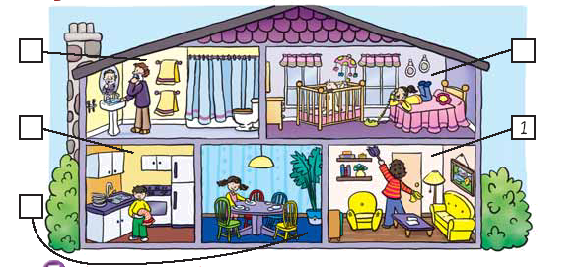
MATCH

1- LIVING ROOM
2- DINING ROOM
3- KITCHEN
4- BATHROOM
5- BEDROOM

POLLY

WRITE THE FAMILY IN THE RIGHT BOX

FATHER
MOTHER
SISTER
BROTHER
LOOK AT THE PICTURE AND COMPLETE WITH ONE WORD FROM THE BOX

1- POLLY’S MOTHER IS IN THE __________ SHE IS __________
2- POLLY IS IN THE ________ SHE IS _________THE TABLE
3-POLLY´S FATHER IS IN THE __________ HE IS _______ HIS FACE
4-POLLY´S SISTER IS IN THE _________SHE IS _________ ON THE PHONE
5-POLLY’S BROTHER IS IN THE _________ HE IS ________THE DISHES
CHOOSE THE RIGHT OPTION

1- YOU SLEEP ON THE ________
A) COOKER B) BED C) TABLE

2-YOU COOK ON THE __________
A) BED B) COOKER C) FRIDGE

3- YOU EAT ON THE _________
A) CHAIR B) COOKER C) TABLE

4) YOU HAVE A SHOWER IN THE____
A) BEDROOM B) KITCHEN C) BATHROOM

5) YOU WASH YOUR HANDS IN THE
A) COOKER B) WASHBASIN C) FRIDGE

LIVING ROOM KITCHEN DINING ROOM BATHROM BEDROM

TALKING CLEANING SHAVING WASHING LAYING

ANSWER THE QUESTIONS

1-WHERE IS POLLY?
2-WHAT IS SHE DOING?
3-IS POLLY’S SISTER IN THE BATHROOM?
4-HOW MANY CHAIRS CAN YOU SEE IN THE DINING ROOM?
5-IS THE HOUSE SMALL?
6- WHERE S POLLY’S MOTHER?
7- WHAT IS SHE DOING?
8-IS THERE A TABLE IN THE KITCHEN?
9-WHERE IS THE FATHER?
10- IS HE HAVING A SHOWER?

COMPLETE THE SENTENCES WITH THE RIGHT PREPOSITION OF PLACE FROM THE BOX

1-THE SOFA IS ……………… THE T.V

2- THE FRIDGE IS …………….. THE COOKER

3-THE COFFEE TABLE IS …………. THE SOFA AND THE ARMCHAIR

4-THE BED IS …………….. THE WINDOW

5-THE TOILET IS …………………THE WASHBASIN

6-THE PICTURE IS ………………THE WALL

ON OPPOSITE NEXT TO BETWEEN

