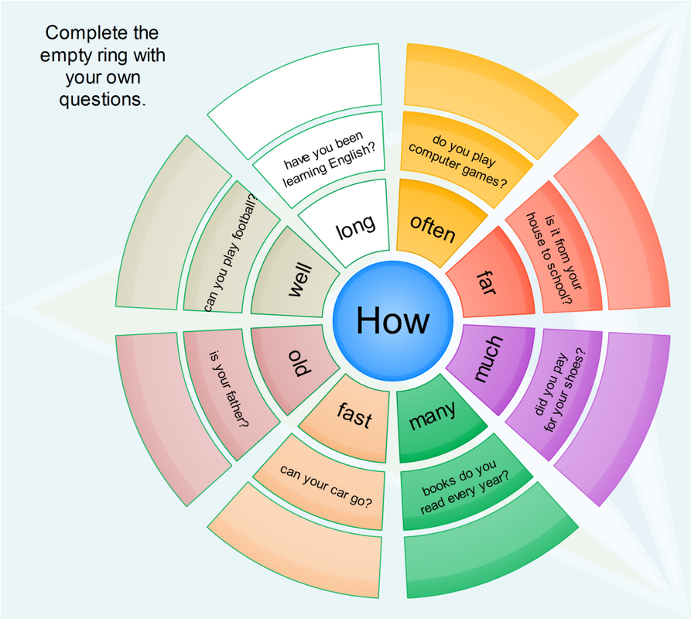
HOW- questions???
1) The word how can talk about a lot of different things. We use it to ask about - the way we do smth How do you get to school?
2) how + adjectives / adverbs: How old – age;
How long – length or length of time;
How tall – height; How far – distance;
How fast – speed; How big – size;
How often – frequency;
How many – number; How much – amount
Pay attention: when the question contains the adjectives tall, high, long, wide, deep, we put the adjective in the answer. Notice the word order: How tall is Adam? Adam is 1.7 metres tall.

I) Complete the questions using much and many.
1. How ______ did your new dress cost?
2. How ______ milk is there in the fridge?
3. How ______ students went to the zoo?
4. How ______ people work here?
5. How ______ water is left?
6. How ______ aunts have you got?
7. How ______ chocolate do you eat?
II) Fill in the gaps with the words given on the right.
1. How____ is the river Thames?
2. How ____ is your Internet connection?
3. How ____ is Mount Everest?
4. How ____ is your grandmother?
5. How ____ is Lake Baikal?
6. How ____ do you go to the museum?
7. How ____ is that road. Can this lorry pass
along it?
8. How ____ is the memory on your phone?
old
fast
long
deep
wide
tall
high
big
often

III) Complete the questions with how and an adjective or adverb if necessary. The answers will help you.
1. ____________is the Panama Canal? It is 150 metres wide.
2. ____________ is the nearest cinema to your house? It’s about one kilometer.
3. ____________ have you been studying English? For about five years.
4. ____________is your mother now? She’s nearly forty.
5. ____________ is the swimming pool? It’s 1, 9 metres at the deep end.
6. ____________ do you go to the theatre? Only about twice a year.
7. ____________ can a maglev train go? Nearly 600 kilometres an hour.
8. ____________ is the village. Not very big, only about 2000 people live there.
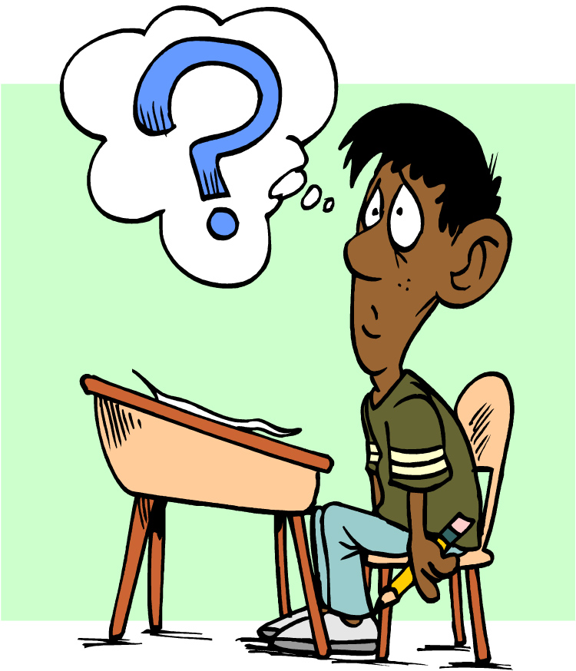

IV) Write questions starting with HOW.
I want to know………
1. if you are well. ___How are you? _____ 5. the distance to the airport. _______________________
2. the price of this car ________________________ 6. if your interview went well. _______________________
3. the age of your brother. ____________________ 7. the amount of water in the bottle. _________________
4. the length of the flight. _____________________ 8. the speed of the train. ___________________________

