Parents angry as COVID-19 shuts schools for a month (3rd March, 2020)
- GAP FILL
Put these words into the spaces in the paragraphs below.

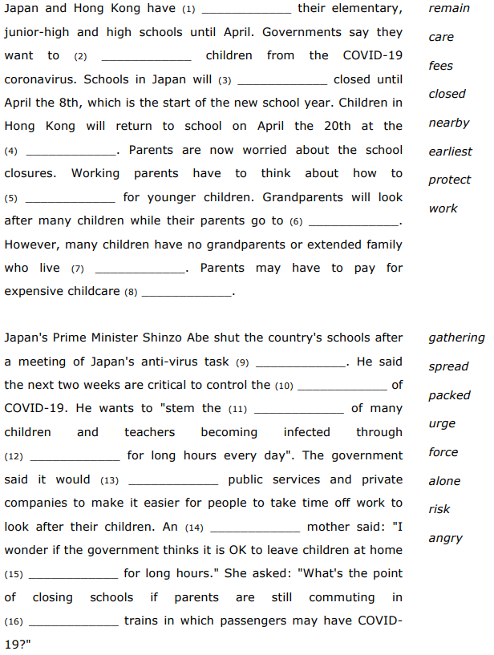
- READING COMPREHENSION
- Read the following statements; determine whether they are true (T) or false (F).

- Japan, Hong Kong and China have closed their high schools. T / F
- Schools in Hong Kong will stay closed until April the 20th at the earliest. T / F
- Parents are not at all worried about the school closures. T / F
- Japan has said childcare will be free in March for working parents. T / F
- An anti-task virus force met in Japan. T / F
- The next two weeks are important to stop the spread of the virus. T / F
- Japan wants companies to help workers who have children. T / F
- A mother questioned the closures when people use crowded trains. T / F

- SYNONYM MATCH: Match the following synonyms from the article.
- closed  - protect  - remain  - worried  - fees  - force  - critical  - urge  - OK  - packed | - safeguard  - acceptable  - charges  - stay  - important  - concerned  - encourage  - shut  - crowded  - group

