

Great Britain (3)

**Read the words in the box below and then use them to answer the questions or complete the sentences:**

|  |
| --- |
| 10 Downing street Teresa May umbrella tea  London tennis BBC Fish & Chips 17  18 cream The Tower of London  Fish and Chips |

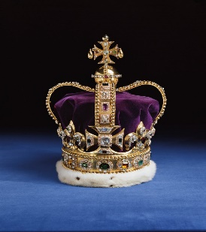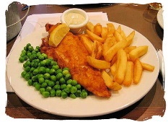

1. Traditional British food. ___________
2. National TV and radio broadcaster. _________
3. 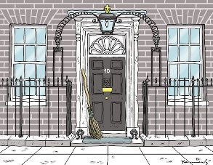Where the Prime Minister lives. _________
4. You can leave school at the age of _________.
5. The Queen keeps the crown jewels in _____________.
6. 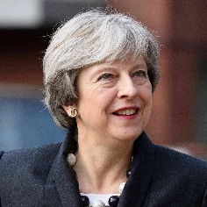Who is the Prime Minister 2018? _____________
7. 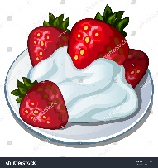The largest city in England. ____________
8. 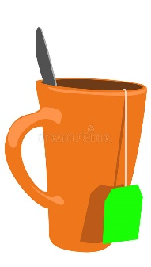A brolly is an __________.
9. 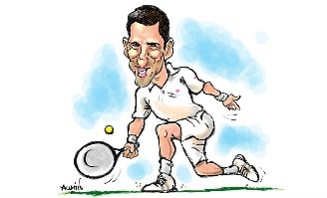In the UK, you can drive when you are _________.
10. Wimbledon is famous for ___________.
11. The British love to drink a lot of _______ .
12. 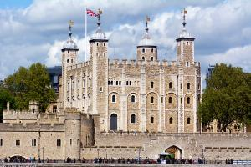Strawberries are eaten with sugar and _________