

Great Britain (1)

**Read the words in the box below and then use them to answer the questions:**

|  |
| --- |
| Windsor reception surname Boxing day London  full English pound Fish & Chips six Wales  UK Prince Charles Kate Middleton  Northern Ireland |

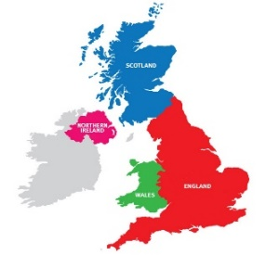

1. The capital of England is _______ .
2. The currency of Britain is ____________ .
3. 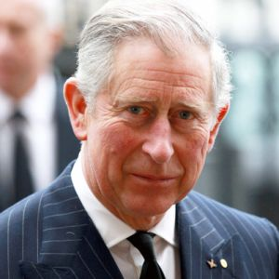Great Britain is made up of Scotland, England, ___________ and _________.
4. How do you abbreviate United Kingdom _______
5. How do you address British teachers? By their ______ .
6. How many wives did King Henry the 8th have? _______ .
7. 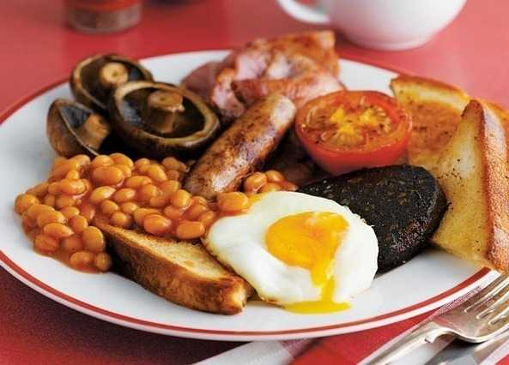The surname of the Queen. __________ .
8. Name of holiday –Dec 26! __________ .
9. Nickname for traditional English breakfast. ________ .
10. 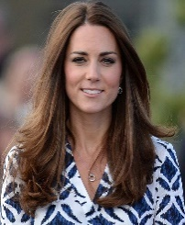What is year one at school called? ___________ .
11. Who will be king of England? ____________ .
12. Who is Prince Williams’s wife? ______________ .

POUND UK I

RECEPTION CALSS LONDON

ENGLISH

BOBBY SURNAMES

WELSH UNIFORM

RED UNION JACK

WALES

SMITH FULL ENGLISH

FROM

THE ISLE OF MAN TUDOR  
  
 PRIMARY THE SAUSAGES

SIX ONEHUNDREDNINTY-FIVE  
  
 SEVEN TIMES CRICKET

BOXING DAY PIE DIANA