HEALTH PROBLEMS: DEALING WITH PROBLEMS

1. Match the pictures (A, B, C…) with the situations (1, 2, 3…). Write the numbers on your left.
2. Match the situations in exercises 1 and 2 (1, 2, 3…) with the correct answer (a, b, c or d). Write the letters on the right:
A  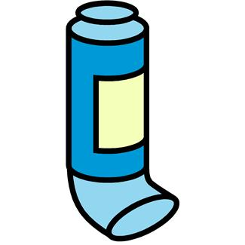 |  | 1. Read the situations and circle the odd one out:  1. To disinfect a bruise, you need ………………  a) antiseptic b) cotton c) sticking plaster d) alcohol  2. Henry’s got flu. He shouldn’t …………………  a) stay in bed b) drink hot milk c) take antibiotics d) relax  3. My grandfather can’t hear well. He should ……………  a) visit a specialist b) play loud music c) use a hearing aid d) check his ears  4. He needs glasses because of his ………………………  a) squint a) short-sightedness c) myopia d) deafness  5. Before buying some glasses, you have to visit the……………  a) a specialist b) ENT specialist c) ophthalmologist d) optician  6. Dad smokes a lot, so he may suffer from ……………… cancer.  a) larynx b) throat c) lung d) skin  7. Carol coughs a lot. She should take some cough …………………  a) pills b) syrup c) medicine d) suppository  8. Tom’s got a terrible headache. He’d better take ……………  a) an aspirin b) alcohol c) a break d) a painkiller  2. Which is the option that best suits the situation:  9. Carol has got asthma. She always carries …………  a) a hearing aid b) drops c) an inhaler d) a healer  10. If you lay in the sun without protection, you’ll get…………  a) sunshone b) sunstroke c) sunstuck d) sunheated  11. Jane fall off the bike and ……………… her ankle.  a) sprained b) cut c) spread d) slipped  12. Tony broke his leg. Now he needs …………………… to walk.  a) a stretcher b) crutches c) a wheelchair d) a club  13. My new shoes are killing me. I’ve got ……………  a) bruises b) breaks c) sprains d) blisters  14. Tony broke her arm and now he needs …………………  a) a sling b) a swing c) a crutch d) a stick  15. My brother has got measles. He shouldn’t ……………  a) stay at home b) relax c) scratch himself d) put some cream on  16. Some old people need ………………… to eat.  a) fake teeth c) false tooth c) false teeth d) dental teeth | 1
B 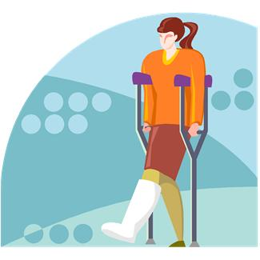 |  |  | 2
C  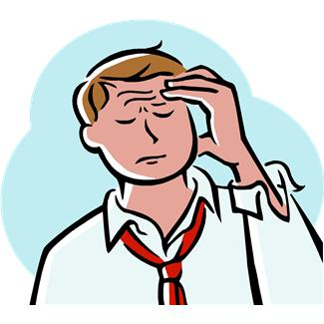 |  |  | 3
D  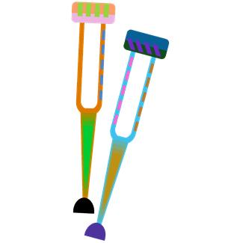 |  |  | 4
E 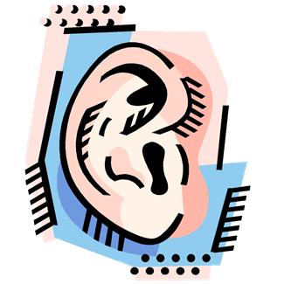 |  |  | 5
F  |  |  | 6
G 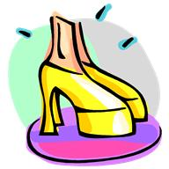 |  |  | 7
H 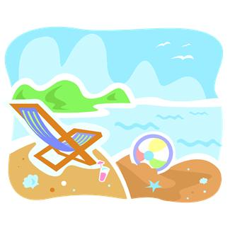 |  |  | 8
I  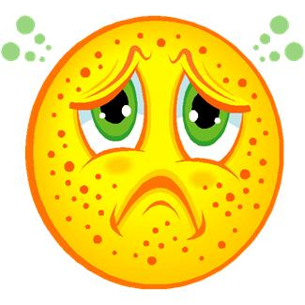 |  |  | 9
J 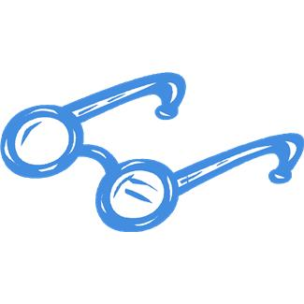 |  |  | 10
K  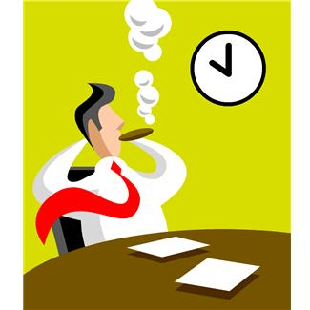 |  |  | 11
L  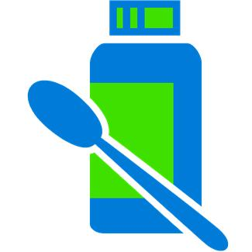 |  |  | 12
M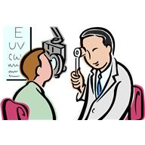 |  |  | 13
N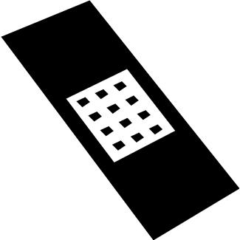 |  |  | 14
O  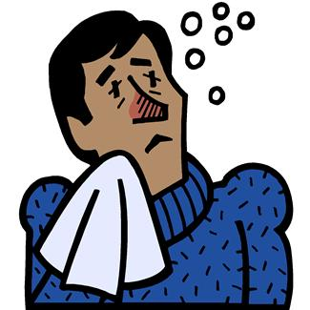 |  |  | 15
P  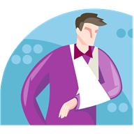 |  |  | 16

KEY

EXERCISE 1:

A 9
B 11
C 8
D 12
E 3
F16
G 13
H 10
I 15
J 4
K 6
L 7
M 5
N 1
O 2
P 14

EXERCISE 2:

1 c
2 c
3 b
4 d
5 b
6 d
7 d
8 b
9 c
10 b
11 a
12 b
11 a
12 b
13 a
14 a
15 c
16 c

