MORE SERIOUS HEALTH PROBLEMS
A  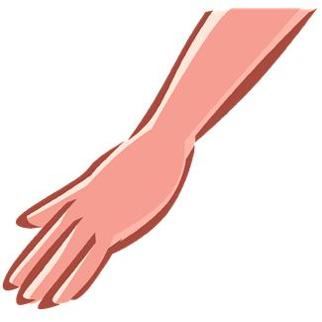 |  | 1. Match the pictures (A, B, C…) with the sentences (1, 2, 3). Write the numbers on the left of the pictures.  2. Choose the missing words on your right to fill in the sentences:  1. My mother needs a ……………………… to make her heart work.  2. Paul had such a terrible accident that ………………………… was crucial to save his life.  3. …………… can be transmitted when sharing infected ……………  4. If a tsetse fly bites you, you can get ………………………  5. Fortunately more and more women with …………………  cancer can have a god quality of life.  6. Some people attend regular AA meetings to control their …………………………………  7. Sally can’t speak. She’s …………………… from birth.  8. Sam cut his arm when operating a machine at work and now he’s got a/an ……………… one.  9. Most patients with cancer have to undergo ……………………… and …………………………… treatment to overcome the disease.  10. People using computers for long hours can suffer from……………………… ……………………………  11. Middle-aged men should undergo regular check to prevent them suffering from…………………… cancer.  12. Stress, cholesterol and sedentary life made of Peter a candidate to …………………………… attacks.  13. Due to his ………………… ulcer, he needed frequent blood ……………………………  14. Alzheimer causes irreparable ………………………… damage.  15. The train derailment caused a large number of ……………………  16. Research on …………………… cells can improve people’s health.  17. My left ear aches so much! It looks like ……………… so I’ll visit my ……………………………  18. Mary’s pregnant. Her ……………………… says the baby is perfect.  19. Severe diabetes can lead to ………………………………  20. Susan broke her leg and after the operation the …………………………… surgeon advised her some …………………………… treatment. | GASTRIC  ETN SPECIALIST  PACEMAKER  RADIOTHERAPY  NEEDLES  RESUSCITATION  OTITIS  MALARIA  OBSTETRICIAN  AIDS  PHYSIOTHERAPY  BLINDNESS  DISC  CHEMOTHERAPY  TRANSFUSIONS  DUMB  STEM  CASUALTIES  ORTHOPEDIC  SLIPPED  PROSTATIC  BREAST  DIPSOMANIA  HEART  ARTIFICIAL  BRAIN
B
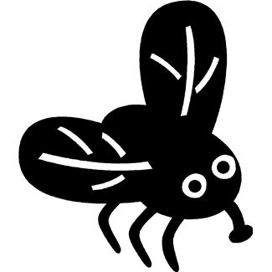
C

D
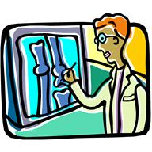
E
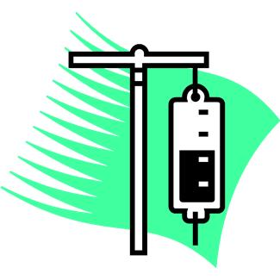
F 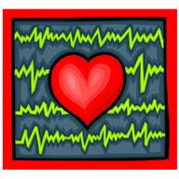
G
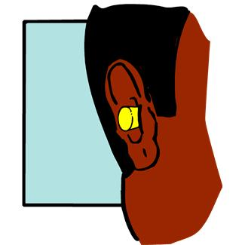
H

I
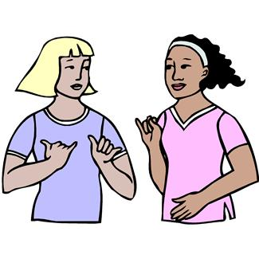
J
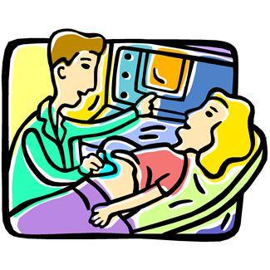
K
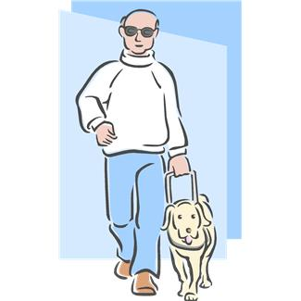
L
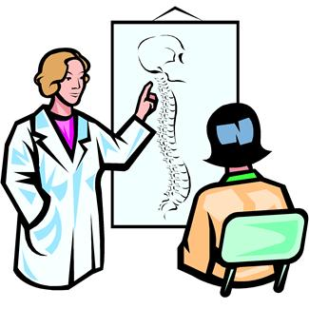
M
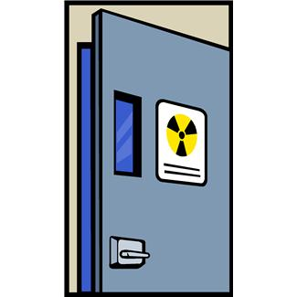
N 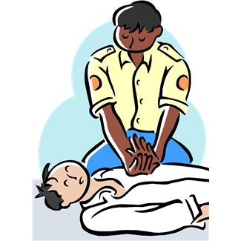
O
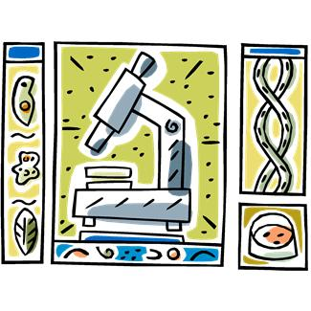
P

Q
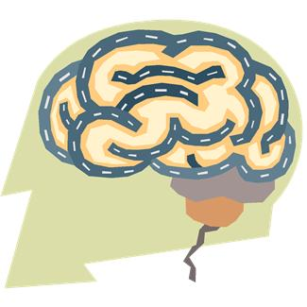
R
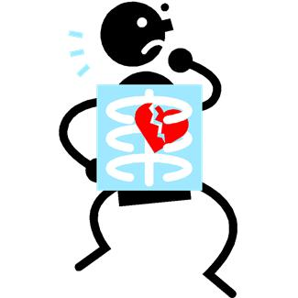
S
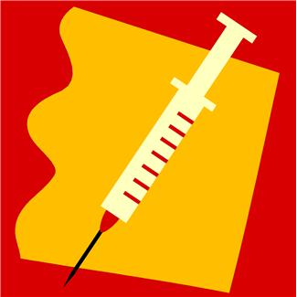
T


KEY

EXERCISE 1

A 8
B 4
C 11
D 20
E 13
F 1
G 17
H 6
I 7
J 18
K 19
L 10
M 9
N 2
O 16
P 15
Q 14
R 12
S 3
T 5

EXERCISE 2

1 PACEMAKER
2 RESUSCITATION
3 AIDS / NEEDLES
4 MALARIA
5 BREAST
6 DIPSOMANIA
7 DUMB
8 ARTIFICIAL
9 CHEMOTHERAPY/ RADIOTHERAPY
10 SLIPPED DISC
11 PROSTATIC
12 HEART
13 GASTRIC/ TRANSFUSIONS
14 BRAIN
15 CASUALTIES
16 STEM
17 OTITIS/ ENT SPECIALIST
18 OBSTETRICIAN
19 BLINDNESS
20 ORTHOPEDIC/ PHYSIOTHERAPY

