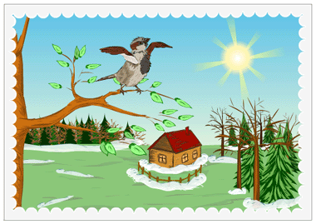
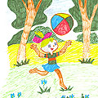
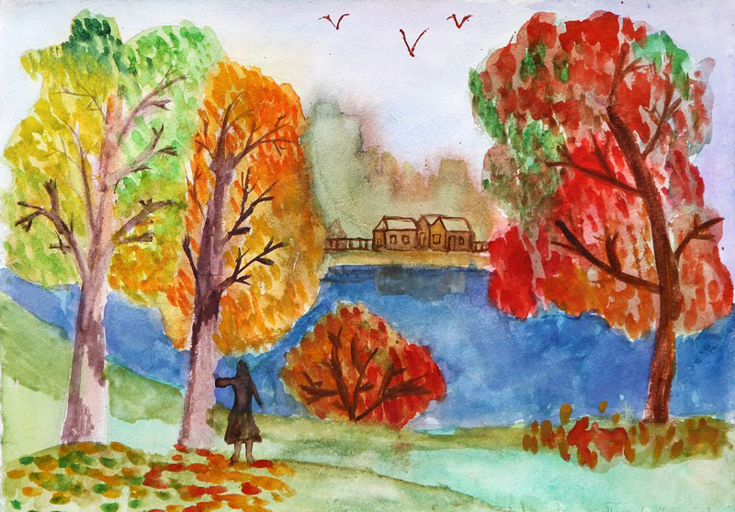

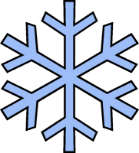
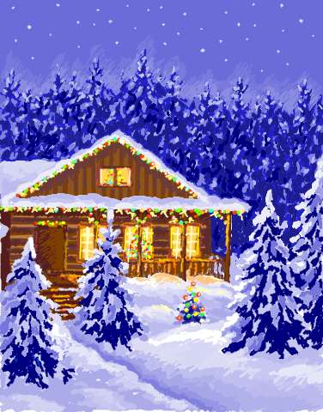

Adjectives: cold, icy, frosty, fresh, cloudy, windy, windless, snowy, sunny, clear, lovely, dull, depressive, terrible, slippery, short.
Nouns: temperature, below zero, snow, snowfall, snowstorm, blizzard, snowflake, snowdrift/snowbank, frost, ice, icicle.
Verbs: come, freeze, cover, draw, sparkle, laugh, hide, move, catch, wear, sting.
Phrases: become longer, catch snowflakes, make a snowman, throw snowballs, make a snow wall, ski, skate, go sledging, swim in the snow, decorate the houses and trees for Christmas, make seed- cans and feed birds, wear warm clothes, the frost sting, have winter holidays.

Adjectives: fine, lovely. sunny, dry, warm, cloudy, dull, foggy, rainy, wet, unpleasant, windy, windless, awful.
Nouns: temperature, above zero, the sun, the sky, wind, rain, breeze, shower, raindrop, rainbow, thunderstorm, fog, smog, buds, birds, nest, leaves, flowerbed, humidity.
Verbs: come, return, melt, run, sing, blossom, appear, come out, open, enjoy, watch, sing, make, plant, water, clean, rake, dig, cut, fly.
Phrases: snow melts, watch the leaves coming out, make nests, dig the ground, plant seeds, plant flowers, water the flowers, cut dry branches, listen to singing birds.

Adjectives: nice, lovely, warm, hot, sunny, windy, windless, rainy, cloudy, dull, stormy, green, dry, calm, light, strong, pleasant, long.
Nouns: the sun, sunrays, wind, breeze, rain, raindrops, shower, thunderstorm, lightning, rainbow, deluge, hail, temperature, fog, smog, tornado, dust storm, sandstorm, hurricane, beach, berries, harvest, mushrooms.
Verbs: come, finish, grow, water, swim, dive, lie, become, enjoy, travel, spend, eat, play, gather, make.
Phrases: become longer, have summer holidays, water flowers, go to the beach, lie in the sun, become sunburnt, enjoy the holidays, gather berries and mushrooms, swim in the river, eat fruit and vegetables, go diving.
1. Describe your favourite season using the words and phrases under the pictures.
2. Describe the weather in all the seasons using words and phrases under the pictures.

Winter
Summer
Spring
Autumn
Seasons And Weather

Adjectives: gold, beautiful, lovely, warm, cool, sunny, windy, cloudy, rainy, wet, humid, dull, terrible, nasty, cold.
Nouns: rain, rainfall, shower, humidity, wind, windstorm, fog, smog, mist, cloud, dew, precipitation, temperature, harvest, fruit, vegetables, seeds, colours.
Verbs: come, enjoy, be over, gather, cut, dig, fall down, rake, shorten, return, study, fly away, put on, make, chop, clean, become.
Phrases: enjoy the gold autumn, become shorter, watch the leaves of different colours, leaves are falling down, throw the leaves, rake the leaves, chop dry branches, gather seeds, dig the land, the birds fly away, start school, prepare for Halloween, put on warm clothes.

