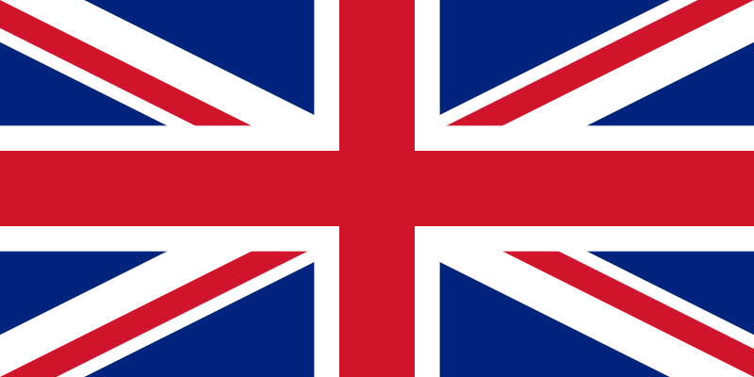
Great Britain | The United Kingdom | The British Isles
England  Scotland  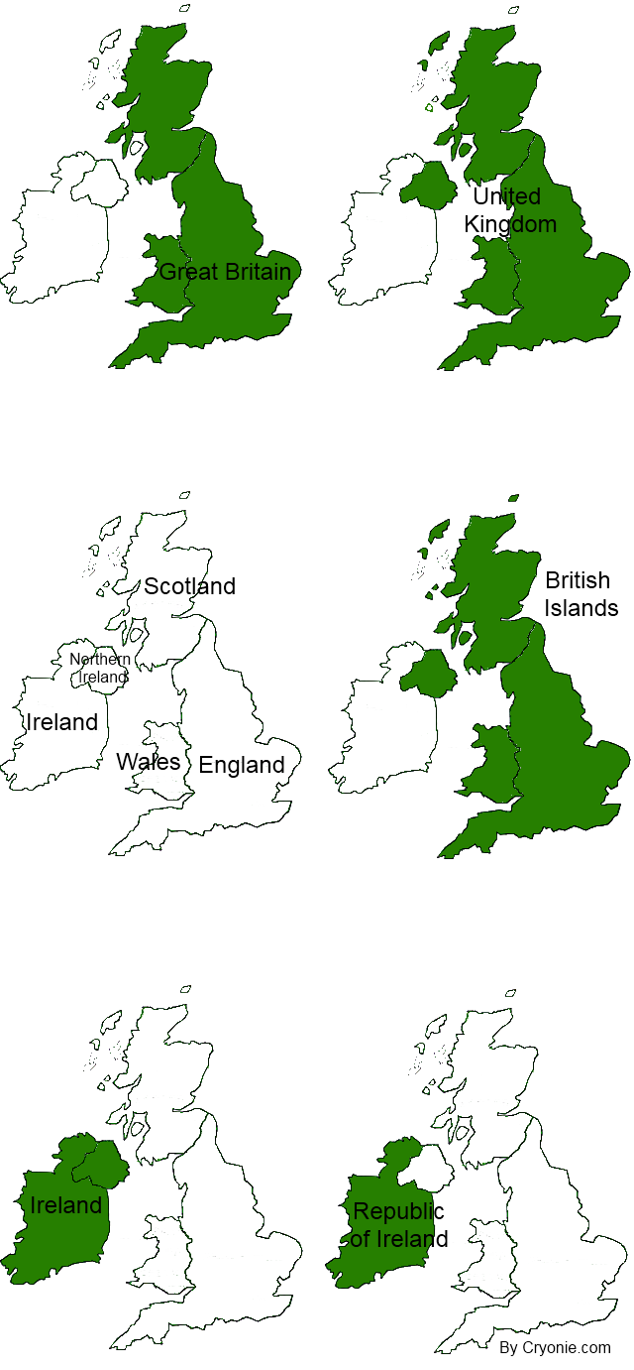  Wales  Questions:  - What is the full name of the British Isles?  - What is the capital of England?  - What is the capital of Scotland?  - What is the capital of Wales?  - What is the capital of Northern Ireland?  - What is the capital of Ireland?  - What is the largest city in Great Britain?  - Who is the Head of State in Great Britain?  - What is the currency in England?  - What do people call the UK flag? | England  Scotland  Wales  Northern Ireland | England  Scotland  Wales  Northern Ireland  Ireland  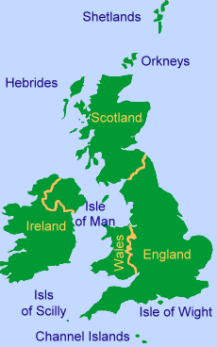  and all of the small, surrounding islands like Isle of Wight, the Orkneys, the Hebrides and the Shetlands

Maps borrowed from http://www.cryonie.com/en/world/great-britain-vs-united-kingdom.php
and http://projectbritain.com/britain/britishisles.htm

Key to the questions:
- The British-Irish Islands
- London
- Edinburgh
- Cardiff
- Belfast
- Dublin
- London
- Queen Elisabeth II
- Pound (Sterling) (GBP)
- Union Jack

