**Types of Houses in England**

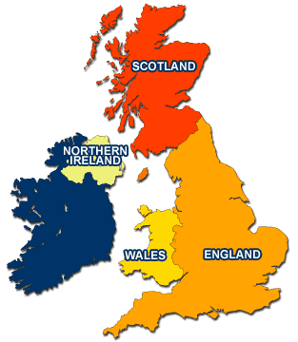

**A detached house is not joined to any other.**

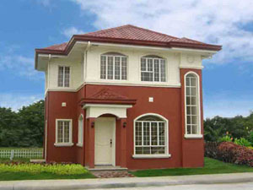

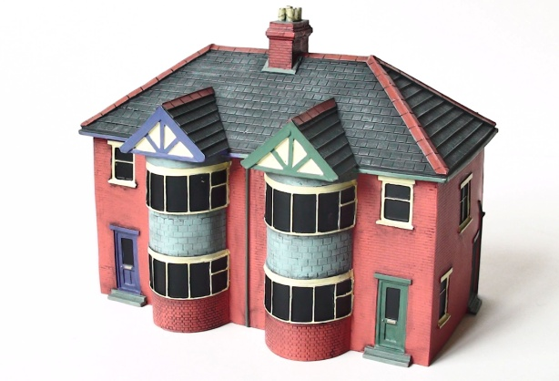

**A semi detached house is a  house which is joined to another house on one side.**

**A terrace house is a house which is part of a line of houses. It is a  house which is joined to other houses on two sides. The house at each end is called an 'end terrace' house.**

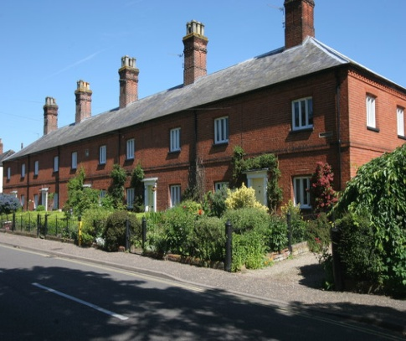

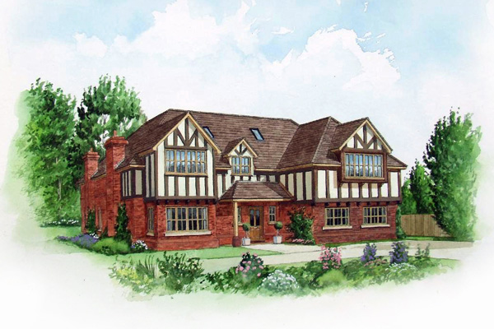

**A Tudor house is a detached house because it not attached to any other house.It was built during the Tudor times about 400 years ago.**

**A bungalow is a house which is only on one floor, no stairs. It may be joined to another bungalow or might stand alone.**

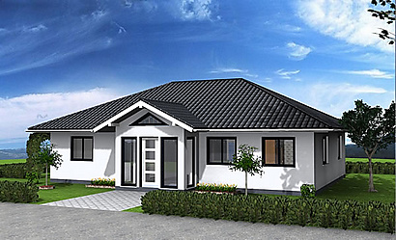

**Cottage is a small house in the country. It also gets used to describe small town houses as well sometimes, if they were originally built for workers to live in, but they are mostly in the country**

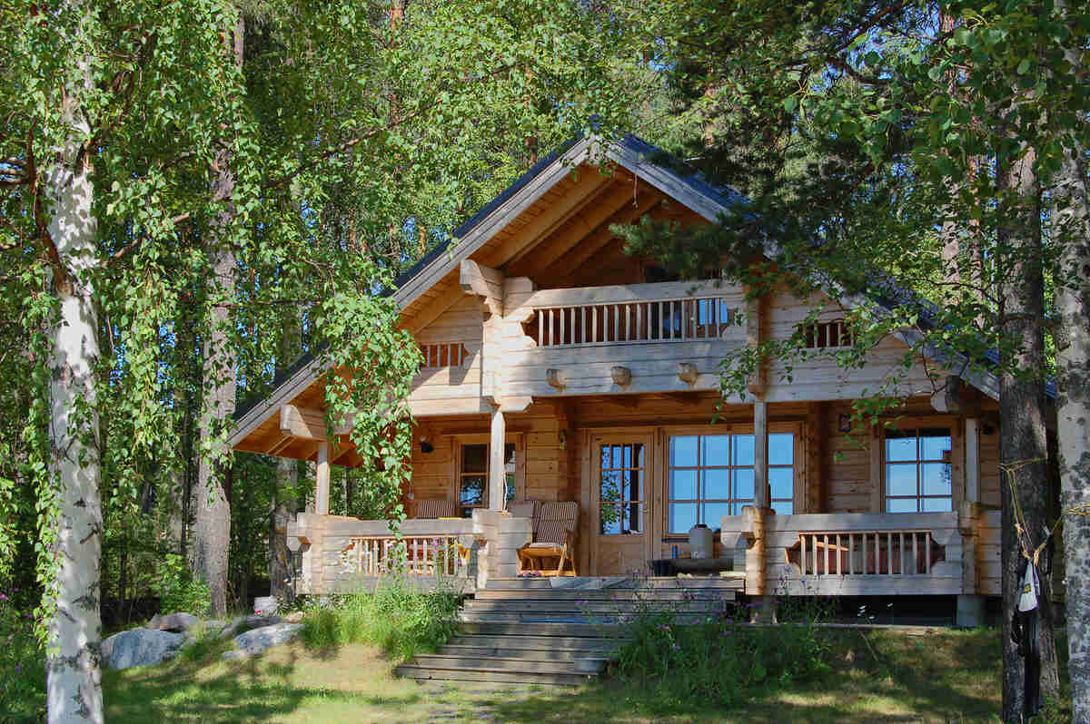

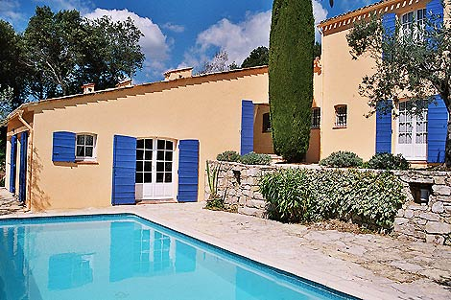

**A villa is a self-contained property abroad for holidays (usually with a private pool).**