The United Kingdom of Great Britain and Northern Ireland
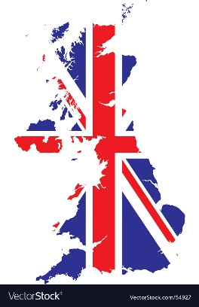
Basic Facts about the United Kingdom of Great Britain and Northern Ireland
The United Kingdom is located in _ _ _ _ _‑west Europe on the island of _ _ _ _ _ _ _ _ _ _ _ _ and the northern part of the _________ of Ireland. It is made up of four countries: ___________, ____________, __________ and ___________ _________. The country’s political system is a constitutional monarchy, which means it has a _______________ and a ____________. At the moment the monarch is Queen Elizabeth II. The country has a temperate _ _ _ _ _ _ _ and is famous for its wet weather.

Early History
The first people to ¹____ the Br _ _ _ _ _ Is _ _ _ were ²____ from Europe. They arrived between 3,500 BC and 3,000 BC and introduced farming, pottery and stone ³____. They lived in the south of England. S _ _ _ _ _ _ _ _ _, a huge circle of standing stones, was ⁴____by these early inhabitants. More settlers from Europe, principally the C _ _ _ _, started to invade Britain from the 10th century BC. As one of their ⁵____ was called the Britons, the whole ⁶____was named Britannia by the R _ _ _ _ _ who occupied the country from 55 BC to the 5th century AD. The Angles and S _ _ _ _ _ came from Germany, Denmark and the Netherlands in the 5th century, and England gets its name from this ⁷____ (Angle-land).
The V _ _ _ _ _ _ arrived from Scandinavia throughout the 9th century, and in 1066 the N _ _ _ _ _ _ invaded from France. These invasions ⁸____ the Celts into what is now W _ _ _ _ and S _ _ _ _ _ _ _, and they remained in I _ _ _ _ _ _. The Battle of H _ _ _ _ _ _ _ changed the future of England as the Duke of Normandy became the king known as William the C _ _ _ _ _ _ _ _.
___island __ settlers __ inhabit __ tools __ built __ invasion __ tribes __ drove
Famous Monarchs
One of the best remembered kings is _ _ _ _ _ VIII who had __ wives. He was well educated and had the mind of a statesman. During his reign, Wales was brought into legal union with England, but he ruled as a true and terrible autocrat. After his quarrel with the P _ _ _ and excommunication, the king became the h _ _ _ of the newly established Church of England and declared its i _ _ _ _ _ _ _ _ _ _ _ from Rome. His second and fifth wife were both executed.
Elizabeth I, a daughter of Henry VIII and Anne Boleyn, ruled not by force, but by female ¹diplomacy. Many European kings wanted to control England but she ²remained unmarried. The “Virgin Queen” kept them hoping and thus managed to ³keep peace with their countries. Although in 1588 the Spanish Armada attempted to ⁴invade England, it ⁵was defeated by the ⁶British navy led by Sir Francis Drake. Great voyages of discovery opened the world to English ⁷trade and conquest during Elizabeth’s reign. Sir Walter Raleigh, who explored the eastern coast of North America, ⁸founded the first English colony there and called it Virginia ⁹in honour of the Queen.

__ not to make war
__ political negotiation
__ established
__ British warships
__ stay unwedded
__ with respect and admiration
__ conquer
__ was crushed
__ business and invasion

- Another monarch who gave her
- She came to the throne in
- The Victorian age was remarkable for
- Industry was replacing
- Many schools
- Queen Victoria reigned
- She was the first monarch
__ agriculture as the basis of the economy.
__ name to an age was Queen Victoria.
__ were built.
__ 1837 at the age of eighteen.
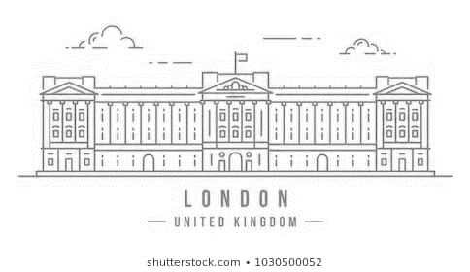
__ the expansion in wealth and power in Britain.
__ to live in Buckingham Palace.
__ for 64 years.

Geography
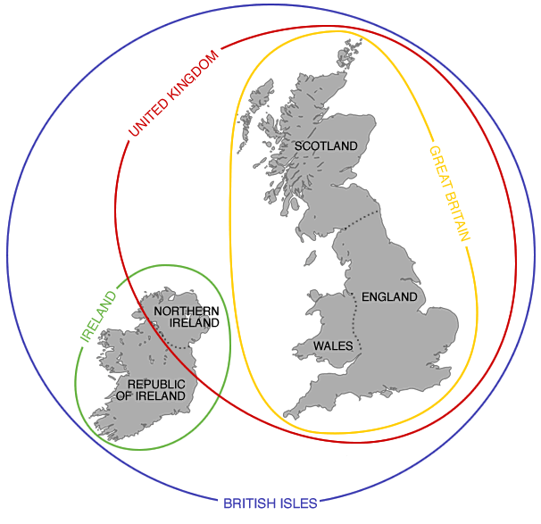
The United Kingdom, also called the U.K., c _ _ _ _ _ _ _ of a group of islands off the northwest c _ _ _ _ of Europe. It is a unique country made up of __ nations: England, Wales, Scotland, and Northern Ireland. England, Wales, and Scotland also make up G _ _ _ _ B _ _ __ _ _. Much of the north and west of the U.K. is covered in high ground, knife-edged mountain ridges separated by deep v _ _ _ _ _ _. This terrain was shaped in the last Ice Age, when thick g _ _ _ _ _ _ _ covered the land. In the south of England, the c _ _ _ _ _ _ _ _ _ _ is mostly rolling hills.
In northwest England and the Scottish Highlands are dozens of _ _ _ _ _ , called lochs. These were left behind when the Ice Age glaciers m _ _ _ _ _. They tend to be long and narrow, and some are very deep. Legends say that a giant monster called Nessie lives in Loch Ness in Scotland.
Political System
Britain is a c _ _ _ _ _ _ _ _ _ _ _ _ _ m _ _ _ _ _ _ _ with Queen _ _ _ _ _ _ _ _ _ II as the Head of State. Parliament, also known as Westminster as it is housed in the P _ _ _ _ _ of Westminster, has two chambers with l _ _ _ _ _ _ _ _ _ _ power: The House _ _ _ _ _ _ _ (lower house) and the House of _ _ _ _ _ (upper house). The m _ _ _ _ _ _ of the House of Commons, called MPs, are e _ _ _ _ _ _ every 5 years. The leader of the party which wins the most seats in the general election becomes P _ _ _ _ M _ _ _ _ _ _ _ and forms the Government which has e _ _ _ _ _ _ _ _ power. Peers in the House of _ _ _ _ _ are not e _ _ _ _ _ _ but appointed by the Queen usually on the Prime Ministers’ advice. Unlike MPs, Lords are not only unelected but also unpaid.
There are also 12 Law Lords who form the S _ _ _ _ _ _ C _ _ _ _ _ : they can return to the House of Lords when they retire from the Court.
Since 1951, Queen Elizabeth II has been Head of State of the UK and 15 other C _ _ _ _ _ _ _ _ _ _ _ countries. She is also Head of the A _ _ _ _ Forces, and Head of the C _ _ _ _ _ of England. In reality, her role is mostly symbolic: she represents her country, is a symbol of national unity and performs many official duties.
British Flag
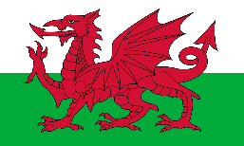
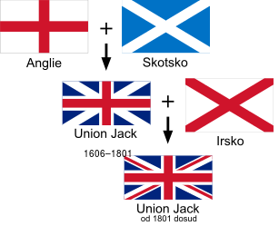
The British flag, popularly known as the U _ _ _ _ J _ _ _ , is made up of the _ _ _ cross of Saint George (patron saint of England), the white cross of Saint A _ _ _ _ _ (patron saint of Scotland), and the diagonal red cross of Saint Patrick (patron saint of _ _ _ _ _ _ _ ) The design dates from 1801 when Great Britain and Ireland united to form the United Kingdom. The patron saint of Wales is Saint _ _ _ _ _ . The Welsh dragon does not appear on the flag as Wales was already united with England from the 13th century.
Royal Family
Queen Elizabeth II of Great Britain is the longest-reigning monarch in British history. She celebrated 65 years on the throne in February 2017 with her Sapphire Jubilee. She is married to Prince Philip and has four children. Elizabeth II is the mother of Prince Charles, heir to the throne, as well as the grandmother of princes William and Harry.
1. __________________________
2. __________________________
3. __________________________
4. __________________________
5. __________________________
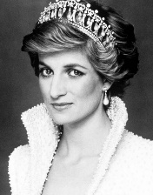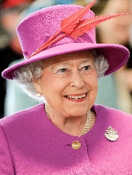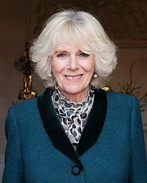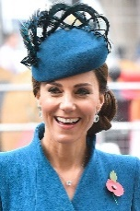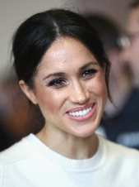

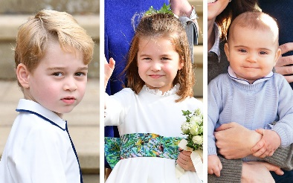
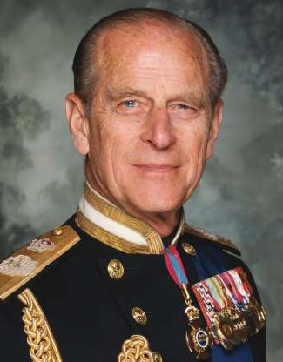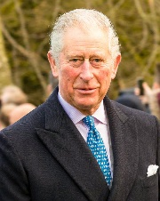
1. ________________
2. ________________
3. ________________
4. ________________

Basic facts about the United Kingdom of Great Britain and Northern Ireland
north; Great Britain; island; England, Scotland, Wales and Northern Ireland; parliament and monarch; climate.

Early History
¹settle; British Isles; ²settlers; ³tools; Stonehenge; ⁴built; Celts; ⁵tribes; ⁶island; Romans; Saxons; ⁷invasion; Vikings; Normans; ⁸drove; Wales and Scotland; Ireland; Hastings; Conqueror.

Famous Monarchs
Henry; 6; Pope; head; independence
¹political negotiation; ²stay unwedded; ³not to make war; ⁴conquer; ⁵was crushed; ⁶British warships; ⁷business and invasion; ⁸established
1 - name to an age was Queen Victoria; 2 - 1837 at the age of eighteen; 3 – the expansion in wealth and power in Britain; 4 – agriculture as the basis of the economy; 5 – were built; 6 – for 64 years; 7 – to live in Buckingham Palace.

Geography
consists; coast; 4; Great Britain; valleys; glaciers; countryside; lakes; melted.

Political System
constitutional monarchy; Elizabeth; Palace; legislative; Commons; Lords; members; elected; Prime Minister; executive; Lords; elected; Supreme Court; Commonwealth; Armed; Church.

British Flag
Union Jack; red; Andrew; Ireland; David.

Royal Family
1 – Diana, Princess of Wales; 2 – Queen Elizabeth II; 3 - Camilla, Duchess of Cornwall; 4 - Kate Middleton, now known as Catherine, The Duchess of Cambridge; 5 - Meghan Markle, now known as Meghan, Duchess of Sussex

1 - Prince Harry, Duke of Sussex; 2 - Prince William, Duke of Cambridge; 3 - Prince Philip, Duke of Edinburgh; 4 - Charles, Prince of Wales
Prince George of Cambridge Princess Charlotte of Cambridge Prince Louis of Cambridge

