Match words and pictures
apartments
1

2

4

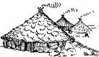

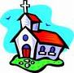
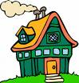
3

castle

cave

1

church
5

6

7

8

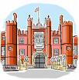
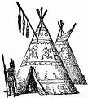
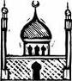
factory

igloo
house
palace
mosque
houseboat
skyscraper
hut
temple
townhouses
villa
tree house
warehouse
wigwam

10

9

11

12

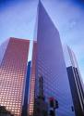
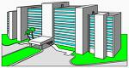
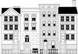
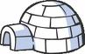

13

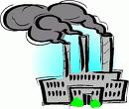
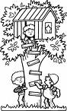
14

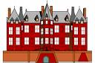
15

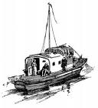
18

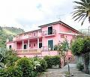
17

16

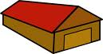

Write the words (more than 1 answer possible)

- Where children play : ………………………………………………………………………………
- Where Neanderthals lived : ………………………………………………………………………………
- People pray here : ………………………………………………………………………………
- Medieval building : ………………………………………………………………………………

